**Boolean Operators "and" and “or"**

So far, you learned how to check for one single condition: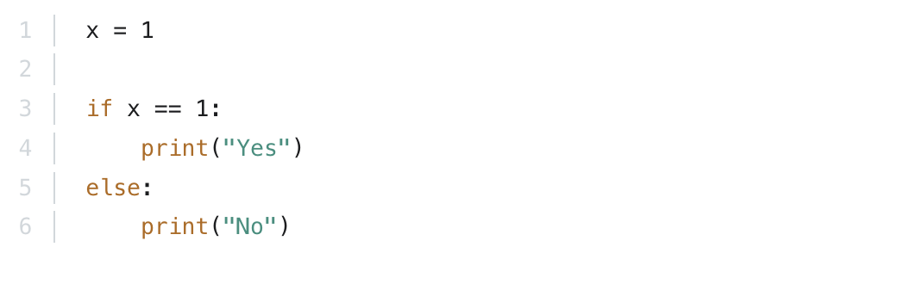

You can also check if two conditions are met at the same time using an and operator:

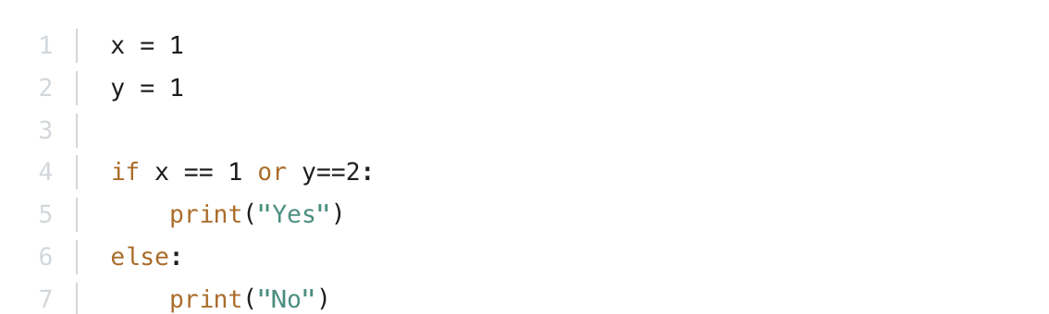

That will return Yes since x == 1 and y ==1 are both True.

You can also check if one of two conditions are met using an or operator:

That will 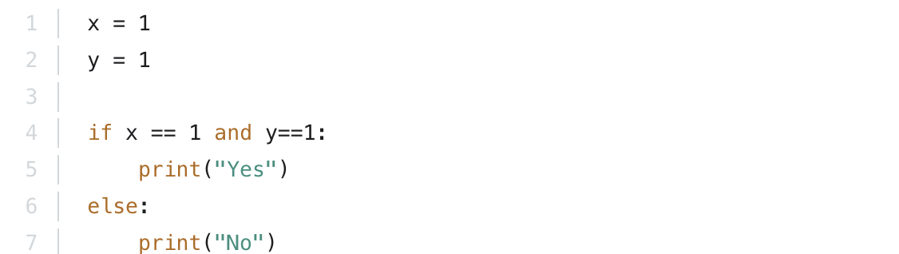return Yes since at least one of the conditions is True. In this case x == 1 is True.